**RUCKUS TQA**

Bayley Fisher

Blake Andrews

Brian McNamee

Stan Katunin

**Version History**

|  |  |  |  |
| --- | --- | --- | --- |
| Date | Version | Notes | Member |
| 9/9/23 | V.1 | * Basic layout. | Blake |
| 13/9/23 | V.1.2 | * Formatting solidified. * Version history added. * Table of contents added. * Milestones added. * Phases added. * Testing Methods added. * Excel forum. | Stan/Blake/Brian |
| 14/9/23 | V.2 | * Marketing | Blake/Stan |

**Contents**

Introduction & Overview

Dev & Client Goals

Milestones

Testing Overview

Testing Techniques

Phases

TQA Form

Identification of Testing Methods

Identification of Data Collected

Marketing

Monetization Strategy

**Introduction & Overview**

**RUCKUS** has just entered beta! The current plan for the project is to **beta test**! We are developing a test plan to essentially go over the bugs in the game and make it the smoothest possible experience for our players – so there is no disparity in the gameplay and mechanics.

**Developer & Client Goals**

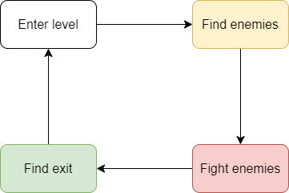

*Gameplay*

Augments, clean fluid movement of the character. Strong impactful weapon attacks, multiple weapons. - only one weapon is available in ruckus with no augments to be seen. It is unclear if augments weren't added or aren't working. The weapon available is a hammer and the impact of the hits are light and strong at times, depending on the attack used.

Shop function. (unclear if there is no shop or if inputs are not working.)

*Genre*

3rd person, roguelike hack ‘n’ slash. We are comparing this with the target market they have highlighted in the GDD to see if their target demographic agrees with the choice of genres.

This also involves testing to see if the game fits the criteria of dark comedy - targeted towards late teens.

*AI behaviour*

Pathing towards player, multiple enemy types, stationary boss. - while there was intention to have multiple enemy types and behaviours. Only one seems to have been implemented.

**Milestones**

**Pre alpha:** Concept and art style solidified. Suggestive feedback on how to improve gameplay.

**Alpha:** Core loops and mechanics of the gameplay. Suggestive feedback on the art style and augments.

**Beta:** Operational gameplay loops with art added. Bugs and glitch defects reported via TQA forms. Systematic feedback on how systems run.

**Gold:** Final product of the game to be released commercially. Impression feedback on how the game feels and runs. The enjoyment of the game and how to adjust post release.

**Post release:** Adjust game based on player feedback. Fix bugs and glitches discovered after commercial release.

**Testing Overview**

|  |  |  |
| --- | --- | --- |
| **Time** | **Place** | **Duration** |
| **12pm** | **In studio** | **2 weeks** |

The testing will be conducted over 2 weeks however there will be multiple testing sessions done giving the team time to alter the game based on feedback where possible.

Since the testing will be conducted in our office environment we will have more control over each session and allow a more personalised approach to each play tester.The testers will focus on the player and how he is controlled, and how he interacts within the gameplay environment. Key focus points for the player are:

* Movement
* Attack
* Camera
* Player fluidity

We will be performing these tests within all 4 areas/levels of the game.

**Testing Techniques**

Highlighting the different testing techniques we will be rolling out for the current gold version of the game. This includes functionality testing.

**Phases**

**Phase 1:** Level 1 playthrough to identify bugs of mechanics, AI pathings and camera controls.

**Phase 1.1:** Report bugs discovered via TQA forms.

**Phase 2:** Level 2 playthrough to identify bugs of mechanics, AI pathings and camera controls.

**Phase 2.1:** Report bugs discovered via TQA forms.

**Phase 3:** Level 3 playthrough to identify bugs of mechanics, AI pathings and camera controls.

**Phase 3.1:** Report bugs discovered via TQA forms.

**Phase 4:** Level 4 playthrough to identify bugs of mechanics, AI pathings and camera controls.

**Phase 4.1:** Report bugs discovered via TQA forms.

**Final phase:** Finalise TQA forms and submit to the team for an update to the game.

**TQA Form**

The TQA forms for **bug tracking** will be documented in the following format:

**Signature: Date: Time: Duration:**

|  |  |
| --- | --- |
| **Bug Priority (urgency):** | Low □ Medium □ High □ Critical □ |
| **Frequency of Occurrence:** | Reliable □ Random □ Undetermined □ |
| **Bug Status:** | New □ Assigned □ Closed □  InProgress □ Resolved □ Reopened □ |
| **Summary:** | *Briefly describe the bug in a sentence.* |
| **Description:** | *Description of the bug.* |
| **Goals & Outcomes:** | *What are the goals of the testing?* |
| **Build/Environment:** | *Build/Version number.* |
| **Expected behaviour:** | *What should happen under normal circumstances.* |
| **Actual behaviour:** | *Explain what is happening.* |
| **Steps to reproduce:** | *How did you get the bug to happen? Replicate the steps.*  *Step 1:*  *Step 2:*  *Step 3:*  *Etc.* |
| **Department/Recipient:** | *Who (person or team) should this be directed to?* |
| **Screenshots/Video:** | *Attach a screenshot or video demonstrating the bug.* |

**Identification of Testing Methods**

Testing method for RUCKUS is **functionality testing**. The goal for our team is to find technical issues in each of the four levels. This requires the group running through the pre-planned excel functionality test sheet for each of their designated levels for RUCKUS.

The excel sheet involves a series of “to do” lists that have each of us testing for basic functionality in each level to see if the game is running as intended.

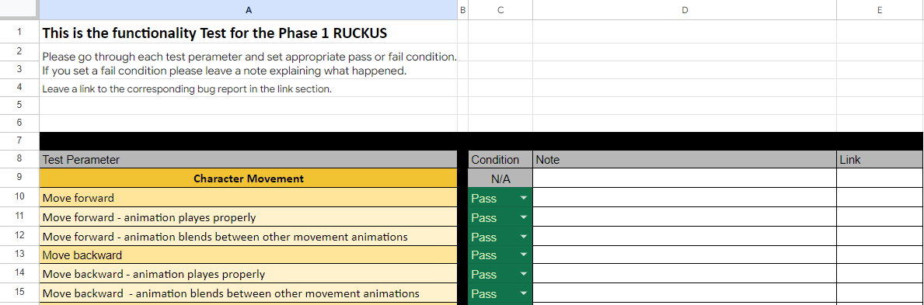

**Identification of Data Collected**

Data unanimously collected for each of the 4 levels is as follows: (This can also be expanded upon via the person assigned to the level.)

|  |
| --- |
| Can the player move?  Forward, Back, Left, Right  Can the player jump?  Vertical, Do they fall down?  Can the player light attack?  Can the player heavy attack?  Can the player sprint?  Stop sprinting  Can the player interact?  Does the player collide with the walls?  Does the player collide with enemies?  Can the player hit enemies?  Do multiple enemies spawn in?  Do multiple enemy types spawn in?  Can the enemies hit the player?  Can the enemies kill the player?  Can the environment kill the player? (If intended in the level)  Does the player take damage?  Can the player pick-up fuel?  Does the rage metre fill?  Can you activate rage metre?  Can the player regain health during the yellow health stage? (via attacking enemy)  Can the player access the shop?  Can they purchase items? Add augments? Remove augments? |

In addition to the excel forms for the 4 levels, there is also a table to fill out for bugs encountered during the different phases for each member.

**Marketing**

Despite the marketing for the game already in full swing and release being imminent (2 months away), it can be recovered. Our proposition is to pitch the game as a beginner roguelike. It’s not finished, it’s not feature complete. It is a way to introduce a new audience into the roguelike gameplay without being thrown into the deep end.

This also includes the game being marketed as a hack ‘n’ slash! It’s entry level. You don’t have to worry about combos or button combinations - you just spam.

**Monetization Strategy**

The price for the game should be lower than the likes of its competitors (DMC5, & Hades), so anywhere below $40AUD. The game admittedly is not feature complete, and ultimately doesn’t come across as a high quality product. This product should be considered to be sold for an extremely low price, or even free. A free model will allow for a larger player base and access to a younger audience which over time could be persuaded to spend money on the game, while the most risky this model has the highest potential for profit post launch. Alternatively charging a small premium i.e $20AUD would mitigate some risk financially but prevent the aforementioned benefits of the free model.

For post launch game content, we want to suggest the next updates to be free content, and paid DLC. For free content, we believe maps and skins will incentivise new players and old players to keep returning to the game. In addition, we also think it would be a good idea to promise the inclusion of augments at some point in an update since it isn’t included in the base game. This way it can seem as if it's a new feature rather than cut content.

In terms of paid content, this can be in the form of paid skins, paid maps, and bosses. This should be the main form of monetization for the game.

Finally a hybrid battle pass with a paid and free track could also encourage players to stay around.

The best way to present this information we believe is to tell your audience the game will continue to get content, and include a content roadmap posted to social media at some point BEFORE release.